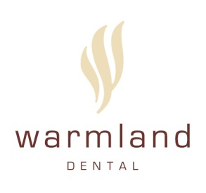
New Patient
PRIVACY, DISCLOSURE, & CONSENT
TO: Warmland Dental and Warmland Health Services
Information for our Patients
At Warmland Dental, all professional dental / orthodontic services are performed by licensed members of the College of Dental Surgeons of British Columbia (“Dental Professionals”), and all institutional health care / orthodontic-related services are performed independently by Warmland Health Services, under the clinical supervision and control of Dental Professionals in a cost-sharing arrangement. Warmland Dental and Warmland Health Services are each independent entities providing independent services but for ease of administration may render joint invoices for their respective services. One or more of our Dental Professionals may have a financial interest in Warmland Health Services.

Privacy Act and Consent to Treatment
By signing this form, you acknowledge and agree that (i) you have read and understood the above information prior to any professional services being provided to you by any Dental Professional; (ii) you have been provided and have read a copy of the Privacy Code for Warmland Dental; and (iii) you agree to the collection, use and disclosure of your Personal Information in accordance with the Privacy Code. You can withdraw your consent at any time on the understanding that withdrawing your consent to certain information handling practices may impair the ability of Warmland Dental to provide the services you are requesting.

Acknowledgement regarding Information Provided
I, the undersigned, certify that I have provided an accurate and complete personal and medical – dental history and have not knowingly omitted any information. I have had the opportunity to ask questions and receive answers regarding my medical – dental history. Should there be any change in either my health status or any other information I have provided, I will advise this dental office. As discussed with me, I authorize the Dental Professionals and all professional staff working under the supervision and control of the Dental Professionals to perform diagnostic procedures that may be required to determine necessary treatment. I understand that information provided from or to my medical doctor or another health care provider may be necessary, and I authorize the exchange of my personal information among Warmland Dental, Warmland Health Services, my medical doctor and another health care provider as reasonably necessary. I have been advised that this office maintains a Privacy Code and have been provided with a copy and that my personal information will be collected, used and disclosed within the guidelines of the Privacy Code. I also understand that my personal information will be retained by Warmland Dental and Warmland Health Services in accordance with their current practices, which may involve transfer and retention outside of Canada. I, the undersigned, acknowledge that the Warmland Dental and Warmland Health Services are relying upon the information which I have provided being accurate and complete.

_____________________________________ ____________________________________ _____________
Print Name of Patient Parent Guardian Signature of Patient Parent Guardian Date

____________________________ _____________
Reviewed by Warmland Dental Date

